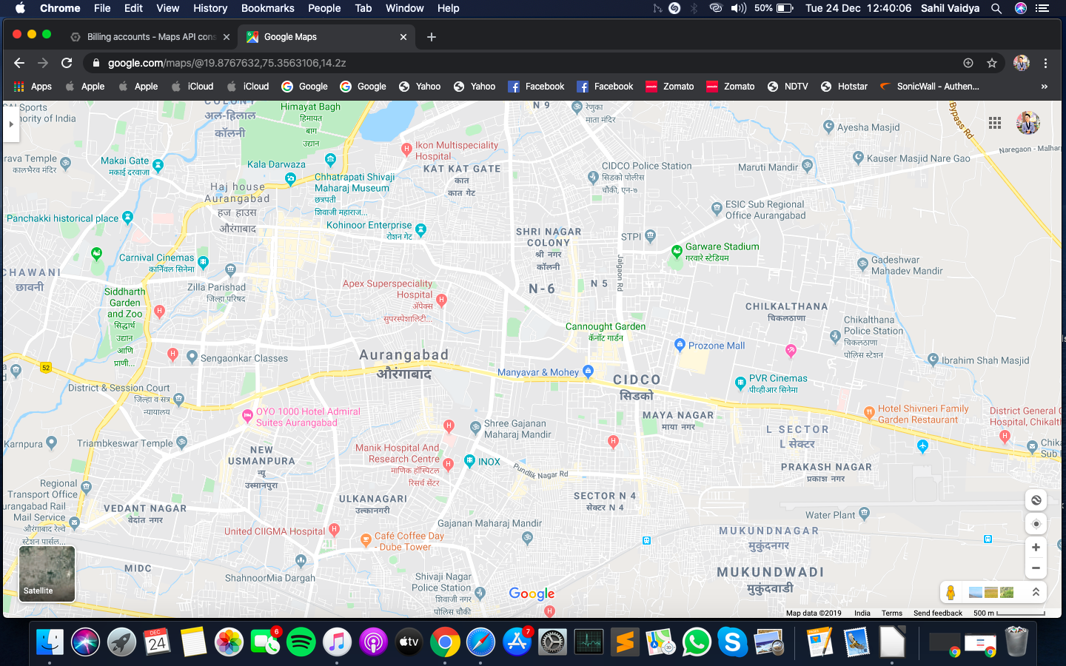

Airport

PVR Cinemas

API CORNER

CIDCO

HIGH COURT

7 HILLS

AKASHWANI

MONDHA NAKA

AMARPREET CHOWK

KRANTI CHOWK

SESSION COURT

BABA PETROL PUMP